**Meeting minutes 18/11/24**

Virtual

**Attendance**

John

Nikodem

Tom

Joe

**Agenda**

1. Discussion of UI planning and current high-fidelity design
2. Discussion current stage of Main document

**Topics Covered**

**UI colour scheme**

Our client liked the design we presented but wasn’t keen on the colour scheme and provide us with a colour scheme from his own website:  
[**https://www.resegva.com/**](https://www.resegva.com/)

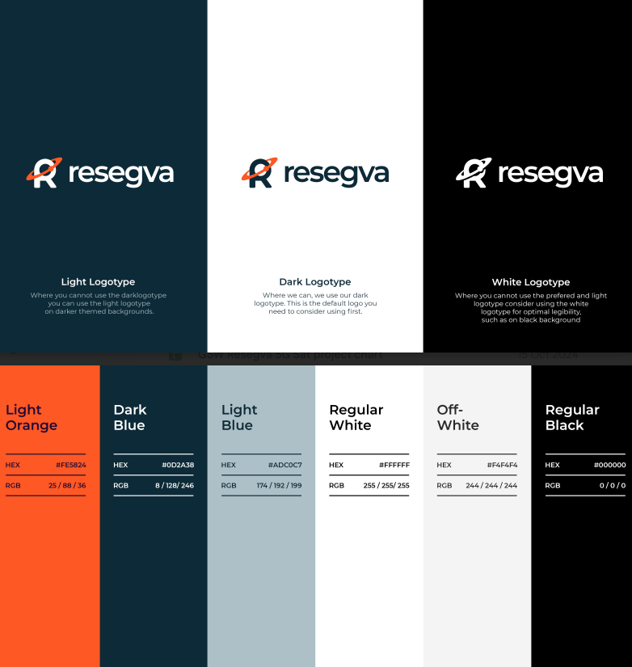

To improve Main Document and our understanding we were tasked with:  
**Application Purpose POV**

* **User Tasks and Priorities:**
  + Define the primary tasks users will perform within the application.
  + Identify what is most important for users to achieve these tasks efficiently.
* **Value to Users:**
  + Clarify the key value propositions of the application.
  + Examples include lifecycle tracking, efficient device management, and easy data access.

**Persona Creation:**

* Assign three team members (one persona each) to create user profiles.
* Each persona should reflect a potential user type and include:
  + Background.
  + Goals.
  + Pain points.
  + Interaction with the app.

**Mission Statement**

* Define a concise mission statement that encapsulates the purpose and goals of the project.
* Highlight the emphasis on lifecycle management, scalability, and user-focused design.